**11 HUMAN BIOLOGY HEART DISSECTION ASSESSMENT**

Name:____________________________ **/20**

**BACKGROUND**

Your heart is a muscular organ which keeps our blood circulating. Functionally you can think of your heart as two pumps, working together as a single organ. It has four muscular chambers covered by a non-wettable shiny membrane called the *pericardium.* It also has valves and associated blood vessels. Your heart is the central organ in your systemic and pulmonary circulations. The structure of your heart muscle, size of its chambers and its valve types all contribute to an efficient pumping organ that maintains the flow of blood to all your body cells.

**MATERIALS YOU WILL NEED**

1 sheep's heart Dissecting tray or board

Scalpel Blunt seeker

Blunt forceps Blunt scissors

Antiseptic Plastic gloves

Newspaper

**PROCEDURE AND QUESTIONS**

Collect your equipment and set out the dissection board on a piece of newspaper.

Place the heart in the centre of the dissection board.

The heart may be surrounded by a sac called the pericardium. This might have been removed. If it is still present remove it using a scalpel and forceps to expose the heart.

1. What is the function of the pericardium?

___________________________________________________________________________________

___________________________________________________________________________________

(1 mark)

Turn the heart and find the pointed end or apex of the heart. This is a part of the left ventricle. The division between right and left ventricles is marked by a diagonal furrow, often covered with fat, on the surface of the heart.

2. Press your finger into the outside walls of both ventricles. The atria are normally small, often wrinkled structures on top of each ventricle. Find each atrium and compare it with each

ventricle. Describe the differences you feel.

___________________________________________________________________________________

___________________________________________________________________________________

___________________________________________________________________________________

___________________________________________________________________________________

(1 mark)

3. How does the thickness of the walls of the atria compare with that of the ventricles?

___________________________________________________________________________________

___________________________________________________________________________________

(1 mark)

4. What would the atria look like if they were full of blood?

___________________________________________________________________________________

___________________________________________________________________________________

(1 mark)

The atria are connected to the systemic and pulmonary circulations by veins with thin walls and large lumens. Find these veins. Sometimes the butcher has removed most of the vein and has left only the entrance to the atrium. However, you can still judge the thickness of the veins.

5. Draw a scientific diagram (only what you see) and label the parts.

(3 marks)

The more obvious blood vessels with thicker walls are arteries. The arteries may branch into smaller arteries but there are essentially two connected to the heart. Try to find these arteries. If you carefully push your finger or a seeker into one of these arteries you should find the path to a ventricle. You should then be able to feel the position of the ventricle from the outside. Do the same with the other artery. This time you should feel your finger or seeker in the other ventricle.

6. You might have found some resistance to your finger or seeker while pushing it through the arteries. What could have caused this resistance?

___________________________________________________________________________________

___________________________________________________________________________________

(1 mark)

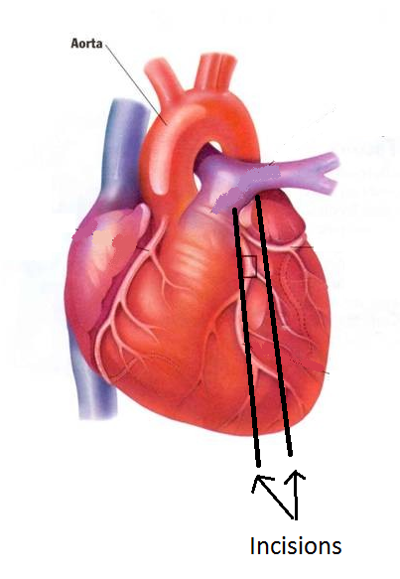Find the diagonal furrow on the outside of the heart. The left ventricle should now be on the right side as you look at the heart.

Use the scalpel to make a cut about 10mm bellow and parallel to the furrow. Cut until you can see clearly into the ventricle. Repeat this 10mm above the furrow. Again, compare the thickness of the ventricle walls.

7. Why is one so much thicker than the other?

___________________________________________________________________________________

___________________________________________________________________________________

(1 mark)

Inside the ventricles you should observe some white cords or thin tendons. These tendons should be connected to flaps of tissue which form the atrioventricular valves at between the ventricles and atria. Use your seeker to try to lift these flaps. Extend your cut if necessary.

8. What is the purpose of these valves?

___________________________________________________________________________________

___________________________________________________________________________________

(1 mark)

9. What are the names of these valves?

___________________________________________________________________________________

(1 mark)

10. What is the purpose of the chordae tendineae (the thin tendons).

___________________________________________________________________________________

___________________________________________________________________________________

(1 mark)

Extend your cuts even further so you can see the arteries leaving the ventricles. Use your seeker to try to lift the flaps of tissue which lie along the artery walls just where they join the ventricles.

11. What would these valves do?

___________________________________________________________________________________

___________________________________________________________________________________

(1 mark)

12. Name these valves.

___________________________________________________________________________________

(1 mark)

Collect your dissection tools and place them in a beaker for cleaning. Keep you scalpels in a separate beaker.

Wrap the heart pieces in newspaper and dispose of them in a plastic bag.

Clean the dissection board with soap and water.

Clean your hands with the disinfectant.

Return any equipment and chemicals to the distribution tray.

Clean up any mess you created on your workspace.

13. Use the names of the blood vessels, chambers and valves you have learned in this exercise to propose a pathway of blood through the heart.

(2 marks)

14. In which **chambers** and **vessels** would you find oxygenated blood from the lungs?

___________________________________________________________________________________

___________________________________________________________________________________

___________________________________________________________________________________

(2 marks)

15. In which **chambers** and **vessels** would you find deoxygenated blood?

___________________________________________________________________________________

___________________________________________________________________________________

___________________________________________________________________________________

(2 marks)